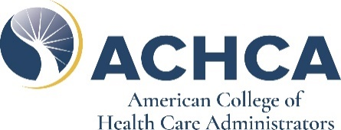
GROUP CONVOCATION REGISTRATION APPLICATION
This discount is only on full registrations. Exclusions: Discount cannot be applied to pre-con, 1 day, 2 day, or other event tickets.
Student/Faculty Full Registrants
10 Students/Faculty: $2125 (15%) 10 Registrants: $5525 (15% discount)
20 Students/Faculty: $4000 (20%) 20 Registrants: $104000 (20% discount)
More than 20 contact ACHCA Staff for a 25% discount More than 20 contact ACHCA Staff for a 25% discount

COMPANY/ORGANIZATION NAME:
Address |  | Invoice Contact 2
City, State, Zip |  | Invoice Email 2
Invoice Contact 1 |  | Invoice Phone
Invoice Email 1 |  | Invoice Fax
Registrant 1: |  | Registrant 2:
Name |  | Name
Credentials |  | Credentials
Title |  | Title
State & Email |  | State & Email
Registrant 3: |  | Registrant 4:
Name |  | Name
Credentials |  | Credentials
Title |  | Title
State & Email |  | State & Email
Registrant 5: |  | Registrant 6:
Name |  | Name
Credentials |  | Credentials
Title |  | Title
State & Email |  | State & Email
Registrant 7: |  | Registrant 8:
Name |  | Name
Credentials |  | Credentials
Title |  | Title
State & Email |  | State & Email
Registrant 9: |  | Registrant 10:
Name |  | Name
Credentials |  | Credentials
Title |  | Title
State & Email |  | State & Email
# | Registrant Type | Total Cost | Mail application with check
10 | Student/Faculty | $2125 | ACHCA
20 | Student/Faculty | $4000 | Attn: Convocation 2024
10 | Full Registrants | $5525 | 1101 Connecticut Ave NW
20 | Full Registrants | $10400 | Washington, DC 20036
Credit Card Account Number:
Expiration Date: Security Code:
Cardholder Name:
Cardholder Signature:
*Fax application with credit card information to 1-800-561-3148

