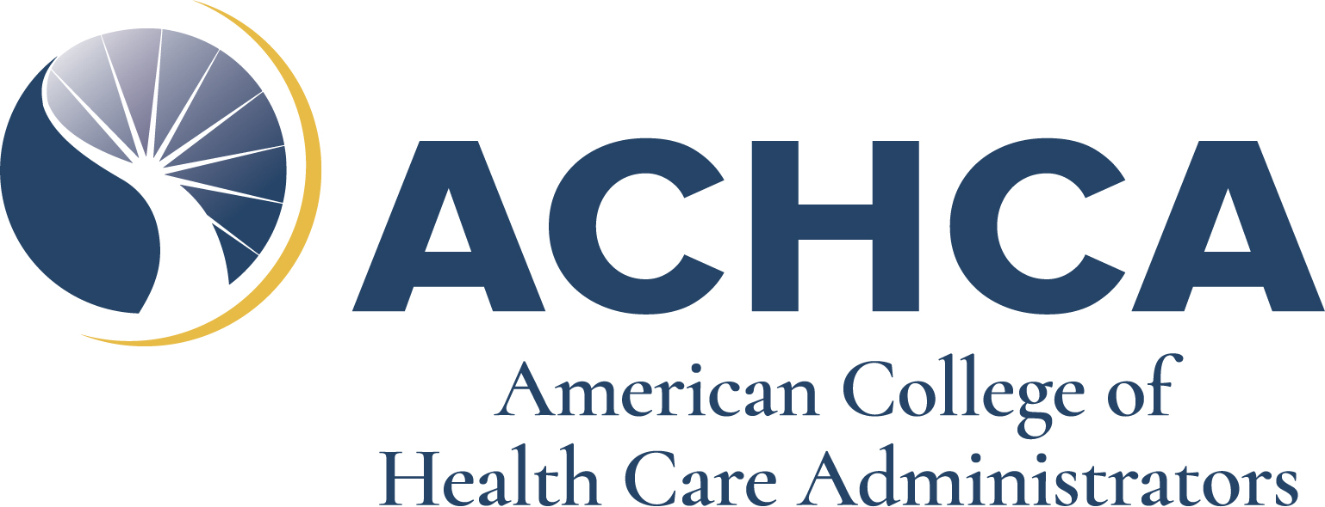

Protégé Scholarship Fund
2024 Convocation and Expo

Please submit this application for financial assistance to Elizabeth Lollis, by email (elollis@achca.org) or by fax: 1-800-561-3148

Name:

E-mail:

Company:

Is your company financially supporting your attendance to the 2024 Convocation and Expo in any way?

Yes No

Do you have other sources of support to attend Convocation? (Employer, Family, Other Grants)

Yes No

Please describe a detailed reason why you are applying for this funding assistance:
(Reasoning must be provided for funding application to be reviewed)

Please sign this document attesting that information submitted in this application is correct to the best of your knowledge.

Signature Date

Limited support funds are available. Approved applicants will receive a portion of their Convocation registration fee to Convocation covered based on need and number of applicants. Funds will be distributed to support attendance at the 2024 Convocation and Expo. Proteges that are given financial assistance are asked to write a short article about their experience.

*Hotel arrangements and other travel related expenses are the responsibility of each protege.*

SUBMIT COMPLETED APPLICATION TO Elizabeth Lollis BY February 17, 2024 to:

Protégé Financial Assistance Form
ATTN: Elizabeth Lollis
EMAIL: elollis@achca.org
FAX: (800) 561-3148

Please submit all mailings electronically or via fax

