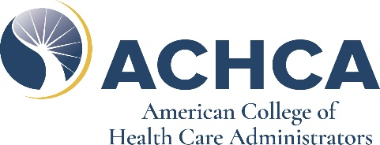
Silent Auction Donation Form
American College of Health Care Administrators
2020 Annual Convocation and Expo

Donor/ Company Name: ________________________________________________________________________
Address: _____________________________________________________________________________________
City: _______________________________________ State: ______________ Zip: __________________________
Phone: ______________________ E-mail: __________________________________________________________
Contact Name: ________________________________________Title:____________________________________

Item Description: ______________________________________________________________________________
Value of Item: $_______________________________________________________(Needed for IRS Regulations)
The amount deductible as a charitable contribution for federal income tax purposes is limited to the fair market value of goods or services provided to ACHCA for purpose of the silent auction.

Full description, including limitations and conditions: _________________________________________________
______________________________________________________________________________________________________
______________________________________________________________________________________________________
______________________________________________________________________________________________________
Please indicate whether you will be shipping your donation or hand carrying it to the conference:

____Item will be shipped directly to winning bidder; a picture of the item will be provided to ACHCA
____Item will be shipped to Hilton Riverside Hotel (To arrive August 29, 2020)
____Item will be hand carried to ACHCA conference registration table at Hilton Riverside Hotel by 2:30pm on Monday, August 31, 2020.

Thank You for Your Support!

Please return your completed form to: Ship Items Directly to Hotel:
ACHCA Hold for Guest: Elizabeth Lollis/864-923-9000
Email: silentauction@achca.org C/O FedEx Office at Hilton Riverside New Orleans
Fax: 800-561-3148 2 Poydras Street
New Orleans, LA 70130
ACHCA Convocation & Expo
Box ____of ____

The American College of Health Care Administrators is a 501(c)(3) non-profit organization
Our Federal Tax ID Number is 36-2637617

